**EX.NO :11**

**DATE : 21/11/20**

**Aim:**

To write a python program to find the GCD of two integers using recursion.

**Program:**

def gcd(a,b):

if(a==0):

return a

if(b==0):

return b

if(a==b):

return b

if(a>b):

return gcd(a-b,b)

else:

return gcd(a,b-a)

a=int(input("Enter first Number:"))

b=int(input("Enter second Number:"))

GCD=gcd(a,b)

print("GCD is: ")

print(GCD)

**Output:**

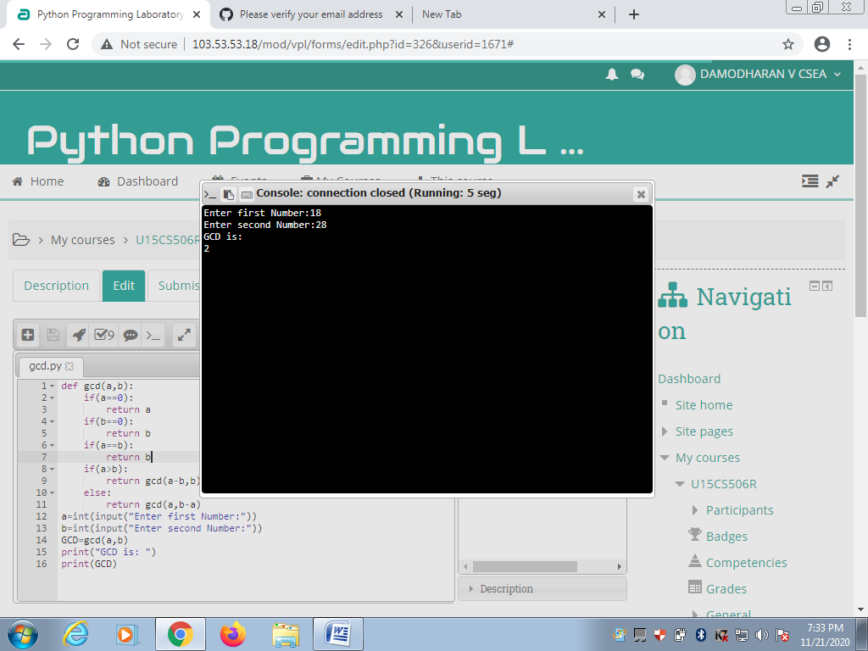

**Result:**

Thus the program to find the GCD of two integers using recursion is executed and the output is obtained.